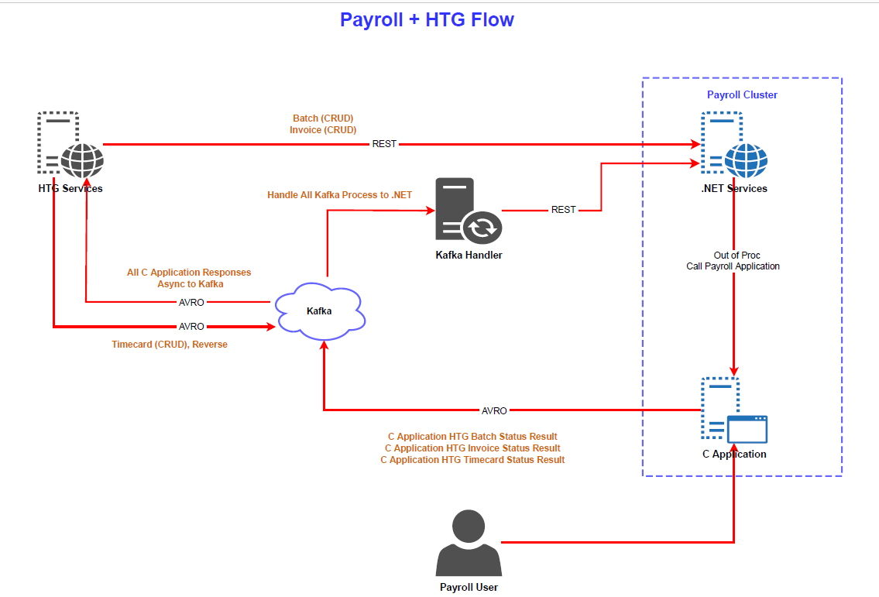

# **Timecard flow:**

***Timecard flow with ML and Kafka***

Add/Update/Delete TC in HTG:

* transmitted to ML
* transmits to Apache server/magic box (converts api xml to payroll xml)
* file goes into htg queue, 1 file per tc
* htg proc takes those timecards and feeds to tcent/tcedit after converting to JSON
* tcent/tcedit queue the tmecard for tccalc in the tcqueue
* tccalc calculates the timecard
* as tcent/tcedit/tccalc process the timecards, they create db updates
* dbupdates get sent out to htgqueue and Kafka
* htgproc manages the send to ML
* ksend manages the send to Kafka
* same data content sent to ML and Kafka*
* from ML it is pushed over to HTG or HTG pulls messages from Kafka

* they may need Payroll to send more information using Kafka

***Timecard flow only with Kafka:***

Add/Update/Delete TC in HTG:

* HTG puts the request in Kafka (Avro)
* C# pulls the request from Kafka (Avro)
* Deserialize Avro object to C# object, serialized to JSON and call the service for Add/Update/Delete
* Service calls cnchelper program with the request
* cnchelper puts the request into htg queue, 1 file per tc
* htg proc takes those timecards and feeds to tcent/tcedit after converting to JSON
* tcent/tcedit queue the timecard for tccalc in the tcqueue
* tccalc calculates the timecard
* as tcent/tcedit/tccalc process the timecards, they create db updates
* dbupdates get sent out to Kafka
* ksend manages the send to Kafka (Avro)*
* HTG pulls messages from Kafka

* they may need Payroll to send more information using Kafka

Current fields for HTG Status returned to Kafka:

{​             "type": "record",

              "name": "HtgTimecardStatus",

              "namespace": "Cnc.Payroll.Avro",

              "fields":

              [

                             {​​"name": "dbCode",      "type": "string"}​​,

                             {​​"name": "timecardNumber",      "type": "long"}​​,

                             {​​"name": "htgTimecardNumber",      "type": "string"}​​,

                             {​"name": "payrollStatus",      "type": "string"}​​,

                             {​​"name": "gross",      "type": "double"}​​,

                             {​​"name": "deleted",      "type": "boolean"}​​

              ]

}​​

**Kafka interface**

* Incoming Kafka topics are managed by the Kafka handler
* Outgoing Kafka topics are managed by the C ksend program

***If HTG uses the Timecard Get Service:***

* Service returns all timecard information

***If HTG uses Kafka to get timecard information:***

* HTG produces Get topic in Kafka with timecard number
* Kafka handler consumes get request
* Kafka handler receives response from Get Timecard service
* Kafka handler produces result for the response topic
* Need 2 topics

**Reverse TC flow:**

* HTG puts the request in Kafka (Avro)
* C# pulls the request from Kafka (Avro)
* Deserialize Avro object to C# object, serialized to JSON and calls the Reverse TC service
* Service calls cnchelper program with the request
* cnchelper program calls tcrev program and reverses the timecard
* dbupdates get sent out to ML and Kafka
* ksend manages the send to Kafka (Avro)
* HTG pulls messages from Kafka

**Undo Reverse TC flow:**

* HTG puts the request in Kafka (Avro)
* C# pulls the request from Kafka (Avro)
* Deserialize Avro object to C# object, serialized to JSON and calls the Reverse TC service
* Service calls cnchelper program with the request
* cnchelper program calls tcuncalc program, uncalculates and deletes the reversal timecard. Updates the original TC from status C to status A.
* dbupdates get sent out to ML and Kafka
* ksend manages the send to Kafka (Avro)
* HTG pulls messages from Kafka

**Delete TC flow:**

* HTG puts the request in Kafka (Avro)
* C# pulls the request from Kafka (Avro)
* Deserialize Avro object to C# object, serialized to JSON and calls the Delete TC service
* Service calls cnchelper program with the request
* cnchelper puts the request into htg queue, 1 file per tc
* htg proc takes those timecards and feeds to tcedit after converting to JSON
* tcedit uncalculates and deletes the timecard
* as tcedit process the timecards, they create db updates
* dbupdates get sent out to ML and Kafka
* ksend manages the send to Kafka (Avro)
* HTG pulls messages from Kafka

**Batch flow:**

* HTG calls the batch service
* Service calls cnchelper program with the request
* cnchelper program calls tcbatch program and enters the batch
* Batch number is returned in the response
* Batch updates flows to the ML and Kafka

**Invoice flow:**

* HTG calls the invoice service
* Service calls cnchelper program with the request
* cnchelper program calls invoice program and enters the invoice
* Invoice number is returned in the response
* Invoice updates flows to the ML and Kafka

**Assumptions:**

* We are assuming things will change as we use it.